Shepherd of the Hills Lutheran Church
Worship with Holy Communion

February 8, 2026
Healing Stories

Welcome & Greeting

Call to Worship

God has set our feet on firm ground.

Our steps are secure.

God has put a new song in our mouths.

We will sing our praises to God.

Confession
We confess our sins before God and one another.
(Pause for silence and reflection.)
God of grace and mercy, we who have seen the signs of Jesus’ presence in the world still fall into doubt and despair. We put our trust in ourselves and in the powers of the world, in material goods and in finite and fallible people. In our fear, we act out against our neighbors and hurt those most in need of our help. Restore our faith,
O God. Forgive us for our failings and make us one with our beloved siblings throughout creation.

Words of Assurance
Your God hears and answers, beloved children, and with love and tenderness washes
away all your sins. As a called and ordained minister in the church of Christ, and by
his power, I declare this good news: You are always whole, always loved, and always
held, even in your doubts and failings. Go forth with joy in this knowledge. Amen.

Prayer of the Day
God of restoration, healing and wholeness come from you. Bless the work of all who
strive for the healing and wholeness of individuals, communities, nations, human
society, and the natural world, that their work might be your work through them,
for the sake of all that you have made. In Jesus’ name we pray. Amen.

First Reading: Psalm 40:1-5 (Please read responsively)

¹ I waited patiently for the Lord; he inclined to me and heard my cry.
² He drew me up from the desolate pit, out of the miry bog,
and set my feet upon a rock, making my steps secure.
³ He put a new song in my mouth, a song of praise to our God.
Many will see and fear, and put their trust in the Lord.
⁴ Happy are those who make the Lord their trust,
who do not turn to the proud, to those who go astray after false gods.
⁵ You have multiplied, O Lord my God, your wondrous deeds and your thoughts towards us; none can compare with you. Were I to proclaim and tell of them,
they would be more than can be counted.

Holy Gospel: John 4:46-54
Lector: Then he came again to Cana in Galilee where he had changed the water into wine. Now there was a royal official whose son lay ill in Capernaum. When he heard that Jesus had come from Judea to Galilee, he went and begged him to come down and heal his son, for he was at the point of death. Then Jesus said to him,

Pastor: “Unless you see signs and wonders you will not believe.” The official said to him, “Sir, come down before my little boy dies.” Jesus said to him, “Go; your son will live.”

Lector: The man believed the word that Jesus spoke to him and started on his way. As he was going down, his slaves met him and told him that his child was alive. So he asked them the hour when he began to recover, and they said to him, “Yesterday at one in the afternoon the fever left him.”

Pastor: The father realized that this was the hour when Jesus had said to him, “Your son will live.” So he himself believed, along with his whole household. Now this was the second sign that Jesus did after coming from Judea to Galilee.

This is the Gospel of our Lord.
Praise to you, O Christ.
Sermon Pastor Janet Kettering

Response to the Word
Eternal God, you call us to ventures of which we cannot see the ending, by paths
as yet untrodden, through perils unknown. Give us faith to go out with courage,
not knowing where we go but only that your hand is leading us, and your love
supporting us. Amen.
Hymn of the Day|God, I'm Just Grateful
https://youtu.be/l3ExlQveoJY?si=sb2XuNAj2FFNhymY

Affirmation of Faith
We are not alone. We live in God’s world.
We believe in God:
Who has created and is creating;
Who has come in Jesus, the Word made flesh, to reconcile and make new;
Who works in us and others by the Spirit.
We trust in God. We are called to be the Church:
To celebrate God’s presence, to live with respect in Creation,
to love and serve others, to seek justice and resist evil,
to proclaim Jesus, crucified and risen, our judge and our hope.
In life, in death, in life beyond death, God is with us.
We are not alone. Thanks be to God. Amen.
Prayers of the people
Let us pray for the church, the world, and all in need.

(A brief silence.)

O God, you have the power to heal and to renew. Mend all that is broken in us and in our world, and bring us to wholeness. God of grace, hear our prayer.

God of light and life, you call your church to shine with your love. Strengthen all who serve in ministry—pastors, assisting ministers, musicians, technicians, and volunteers—that they may faithfully proclaim the good news in word and deed. Guide this congregation as we seek to follow where you lead. God of grace, hear our prayer.

You created the world in beauty and order. We pray for lands and waters, for fields and forests, for creatures great and small. Where creation is wounded by neglect or disaster, bring healing and renewal, and make us wise stewards of all you have entrusted to us. God of grace, hear our prayer.

You are present with all who govern and lead. We pray for leaders of nations, communities, and institutions. Grant them wisdom, humility, and compassion, that their decisions may serve justice, peace, and the common good. God of grace, hear our prayer.

You draw near to all who are in need. We pray for those who are sick, grieving, lonely, or afraid, especially we lift up Pastor Phil, Matt, Brett, Rick and Kelly, Terry, Jim and Sally, Dave, Dorothy, Clover, and all those named on our Prayer Chain. We also pray for those who care for them—family, doctors, nurses, and caregivers—especially James and Chris Elkins and Kirk, Clare, and Gwen Fallon. Surround them with your peace and healing love. Surround them with your comfort and provide for them through caring hands and open hearts. God of grace, hear our prayer.

God of wholeness, we pray for the work of the Joshua School. May our relationship with them reflect your love and care for those with special needs. We pray that all those on the Autism Spectrum, especially those in our faith family, might find fulfillment, joy, and love. God of grace, hear our prayer.

(Other Intercessions offered here)

We give thanks for the saints who have gone before us, whose faith continues to inspire us. Help us to trust your promises and walk in hope until we share in the fullness of your kingdom. God of grace, hear our prayer.

Into your hands, O God, we commend all for whom we pray, trusting in your mercy, through Jesus Christ our Savior. Amen.
Sharing of the Peace
The peace of the Lord be with you all.
And also with you.

(Please share a sign of God’s love and peace with each other.)

Offering/Offering Prayer
All of creation came forth from your hand, O God. Accept now these humble offerings out of the incomprehensible abundance you have made and shared with us. Use our gifts to further the work of healing and wholeness for all the world. Amen.

Celebrating Community: Sacrament of Holy Communion
The Thanksgiving
The Lord be with you.
And also with you.
Lift up your hearts.
We lift them to the Lord.
Let us give thanks and praise to the Lord our God.
It is right to give God thanks and praise.

We celebrate the Spirit of God, who hovered over creation and brought order out of formlessness. We celebrate the Spirit of God, who filled Jesus with power and wisdom
and, through Him, made the life of God available to all. We celebrate the Spirit of God, who has been poured out on all people, and leads us into the reign of God. As we gather at the Lord's table, we recognize the Spirit's Presence among us and we open our hearts to Its influence.

Let us pray: Most Holy and Gracious God, we pray not only for ourselves,
but for others—known and unknown, named and unnamed. Deliver to all the
comfort and peace of your love that surpasses all understanding.

Bless our world, O Lord, and by your Spirit let your harmony and justice prevail. Bless our church, uniting us in the truth of your Word and empowering us in
ministry to the world. Bless our family and friends, watching over and providing peace to them. Bless all who are suffering by embracing them in your loving arms. Bless each person here this morning, keeping us all faithful to you. Amen.

Lord, we come knowing that we depend on you for life and truth and love. We come knowing that you welcome us with open and accepting arms. We come ready to meet with you and be changed by the encounter, remembering that on that night of betrayal and desertion, Jesus took bread, gave thanks, broke it, and gave it to the disciples,
saying: "Take and eat; this is my body which is given for you. Do this in remembrance of me."

When the supper was over, he took the cup, gave thanks, and gave it to his disciples,
saying, “Take and drink; this is my blood of the new covenant, poured out for all
people for the forgiveness of sins. Do this in remembrance of me.”

So now, we eat and we drink and we remember Jesus and his great love for us, praying the prayer he taught us:

Our Father, who art in heaven, hallowed be thy name;
thy kingdom come, thy will be done,
on earth as it is in heaven.
Give us this day our daily bread;
and forgive us our trespasses,
as we forgive those who trespass against us;
and lead us not into temptation,
but deliver us from evil.
For thine is the kingdom, and the power,
and the glory, forever and ever. Amen.

The one who heals all infirmities now invites you to this table of mercy and wholeness, where he meets us in bread and wine, and nourishes us on his very presence. Come and be fed with your siblings in Christ, for all is prepared.

Sharing the Meal
This is the body of Christ, broken in love for you.
This is the blood of Christ, poured out in forgiveness of you.
Communion Hymn| I Received the Living God
https://youtu.be/crgIRDh6IaA?si=6jKPY16ycbPlPc_b

Post-Communion Blessing

Prayer after Communion
Holy, gracious God, here at this table your promise of life is made tangible. We have rested in the depth of your love and tasted your nourishing presence. At this table, you have offered us life. Together, by your grace, we accept that life and give you thanks. Send us from this table as witnesses to the resurrection, that all may know life and love in Jesus’ name. Amen.
Closing Announcements

Blessing & Benediction
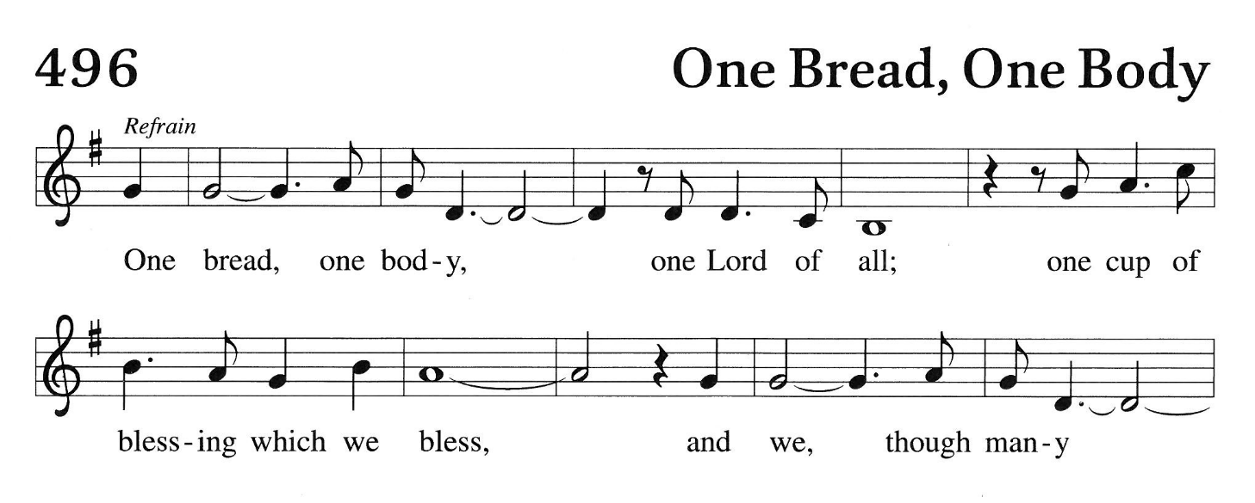
By the tender mercy of our God love has broken upon us! Light is given where once there was darkness and hope where there was only death. We go into this season knowing that God will guide our feet into the way of peace. Amen.

Sending Hymn|Shout to the Lord
https://youtu.be/1NGgmQnHw6o?si=2KPEcdmpY1veVISU

Evangelical Lutheran Church in America

This is Christ's church. There is a place for you here.
We are the church that shares a living, daring confidence in God's grace.
Liberated by our faith, we embrace you as a whole person—questions, complexities and all.
Join us as we do God's work in Christ's name for the life of the world.

Click link to access readings, sermons & special events from past Sundays:
https://www.youtube.com/@shepherdofthehillslutheran6221/videos

WORSHIP RESOURCES:
Call to worship— Narrative Lectionary Worship Resources Copyright © 2025 Clergy Stuff
Confession & Forgiveness— Narrative Lectionary Worship Resources Copyright © 2025 Clergy Stuff
Prayer of the Day— Narrative Lectionary Worship Resources Copyright © 2025 Clergy Stuff
Scripture Readings—New Revised Standard Bible, Updated Edition
Response to the Word—Eric Milner White
Affirmation of Faith—Re-Worship, United Church of Canada
Great Thanksgiving—United Church of Christ, as adapted, and Rev. LL DuBreuil © 2005, as adapted.
Used with permission.
Offering Prayer— Narrative Lectionary Worship Resources Copyright © 2025 Clergy Stuff
Prayer after Communion – Narrative Lectionary Worship Resources Copyright © 2025 Clergy Stuff
Blessing & Benediction – Carol Penner

WORSHIP PARTICIPANTS:
February
Birthdays

Janice I. 2/6
Elizabeth H. 2/15
Kathy W. 2/15
Becca B. 2/21
Caroline M. 2/24
Administrative Assistant: Caroline Michalak
Altar Guild: Gerry & Ken Moorhead, Lynn Trumble & Kay Werpy
Assisting Minister: Rev. Phil Kettering
Audio Technician: Mark "Fuzz" Newkirk
Lector: Cindie Scoby
Pastor: Rev. Janet Kettering

Shepherd Happenings: February 8 – February 15, 2026
Sunday, February 8th – Healing Stories
9:30 a.m. – Hybrid In Person/Zoom Worship with Holy Communion
Coffee & Conversation immediately following Worship

Wednesday, February 11th
11:00 a.m. - Amazing Grace Bible Study

Friday, February 13th
7:00 a.m. —Men’s Zoom Breakfast Bible Study
5:00 p.m.—Friday Night Perspectives Zoom Gathering

Sunday, February 15th– The Man Born Blind (Transfiguration)
9:30 a.m.—Hybrid In Person/Zoom Service of the Worship (No Holy Communion)
Coffee & Conversation immediately following Worship

Daily Narrative Lectionary Readings: Week of February 8, 2025
Monday, February 9, 2025
https://clergystuff.com/nl-devotions/john-51-18-healing-stories2026
John 5:1-18 Healing Stories

Tuesday, February 10, 2025
https://clergystuff.com/nl-devotions/john-519-29-the-authority-of-the-son2026
John 5:19-29 The Authority of the Son

Wednesday, February 11, 2025
https://clergystuff.com/nl-devotions/john-530-47-witnesses-to-jesus2026
John 5:30-47 Witnesses to Jesus

Thursday, February 12, 2026
https://clergystuff.com/nl-devotions/john-61-15-feeding-the-five-thousand2026
John 6:1-15 Feeding the Five Thousand

Friday, February 13, 2026
https://clergystuff.com/nl-devotions/john-616-21-jesus-walks-on-water2026
John 6:16-21 Jesus Walks on Water

Saturday, February 14, 2026
https://clergystuff.com/nl-devotions/john-622-34-bread-from-heaven2026
John 6:22-34 Bread from Heaven

Sunday, February 15, 2026
https://clergystuff.com/nl-devotions/john-91-41-the-man-born-blind-transfiguration2026
John 9:1-41 The Man Born Blind (Transfiguration)
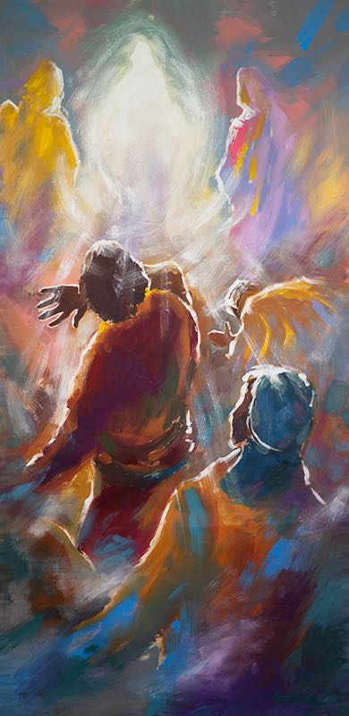

welcome! Thank you for worshiping with us today!
Guests
Please sign our Guestbook and/or fill out the brightly-colored Info Slip and place it in the offering plate. This helps us get to know you better so that we can serve you more effectively.

Do you or someone you know need prayers?
Prayer Changes Things. The Shepherd Prayer Chain members stand by ready to help. You’ll find our Prayer Box on the table to your left as you enter the building, as well as paper and pencils. Please write your prayer request and place it in the box. You are not required to sign your request or give the name of the person for whom we will pray, unless you wish. If you desire a private conversation with Pastor Janet, please contact the Church Office or call her on her cell phone at 507-360-1625. All prayer requests will remain confidential.

Children are cherished at Shepherd!
In our Sanctuary, you’ll see a coloring table and soft toys. Children’s bulletins are available on the table just outside the Sanctuary. If at any time you wish to take your child out for some quiet time, our Nursery/Library is stocked with supplies for
playing, coloring, studying the Children’s Bulletin, or reading.

Remembrance
On the north wall of the Sanctuary a table is set with candles. You are invited to light
a candle in memory of a loved one at any time before, during, or after our worship
service.

Communion
At Shepherd of the Hills, we recognize that the Table of Communion is not our table.
It is not a Lutheran table. It is our Lord’s Table—a meal prepared for all—prepared in love. Please come. All who long for the Good News in Jesus Christ are truly welcome at this table. As Jesus called children to be close to him, we, likewise, extend this
invitation to all children. Should you not feel comfortable receiving the Sacrament, please come forward indicating that you wish to receive a blessing by folding your arms over your chest.

Communion outside of Worship
Arrangements can be made to bring communion to you at a time convenient for you. If, for any reason, you are unable to attend normal services, such as a hospital stay or for personal reasons, and wish to have communion brought to you, please contact the Church Office, Pastor Janet at 507-360-1625, or Dick Werpy at 720-771-6767.

Membership
At Shepherd, we worship as one Faith Family. If you wish to extend your worship to include membership, please see Pastor Janet.



PARTNERS IN WORSHIP

The Ministers: All the People
Pastor: Rev. Janet Colby Kettering
Administrative Assistant: Caroline Michalak
Altar Guild: Ken & Gerry Moorhead, Lynn Trumble & Kay Werpy
Assisting Ministers: Tim Kirchoff & Dick Werpy
Pianist: Margaret Scharff
Prayer Chain Administrator: Kathy Wootton
Shepherd Council:
Michelle Kirchoff, President
Janice Irish, Vice-President
Kelly Mauer, Secretary
Rev. Phil Kettering, Treasurer
Jim Timmermann, Building & Maintenance
Eric Michalak, Cindie Scoby & Pastor Janet Kettering
Audio Technician: Fuzz Newkirk

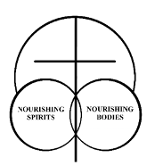
OUR MISSION STATEMENT

Marked by the Cross of Christ Forever, we
† Gather in Love
† Grow in Faith
† Share God’s Love & Grace
† We are Empowered to BOLDLY
Proclaim & Witness God’s Word

7077 Harvest Road, Boulder, CO 80301 Office: 303-530-4422
Email: shepherdboulder@gmail.com Website: www.shepherdboulder.org

